

**Rippingale Parish**

**Community Emergency Plan**

# DISTRIBUTION LIST:

|  |  |  |
| --- | --- | --- |
| **Name** | **Email Address** | **Contact Number** |
| Parish Council Chair  Barry Ross | [chairmanrpc4@gmail.com](mailto:chairmanrpc4@gmail.com) | 07740 151601 |
| Flood Wardens  Tony Creek  Theo Ray | [tonycreekrpc@gmail.com](mailto:tonycreek1966@gmail.com)  [theodoreray1977@gmail.com](mailto:theodoreray1977@gmail.com) | 07886 622349  07425 316852 |
| Parish Clerk  Laura Davies | [rippingalepc@gmail.com](mailto:rippingalepc@gmail.com) | 07375 364742 |
| LCC Emergency Planning & Business Continuity Service | [resilientlincs@lincoln.fire-uk.org](mailto:resilientlincs@lincoln.fire-uk.org) | 01522 580322 |
|  |  |  |
|  |  |  |
|  |  |  |
|  |  |  |

# RECORD OF AMENDMENTS:

|  |  |  |
| --- | --- | --- |
| **Record of Amendments / Revisions to Plan** | | |
| **Date** | **Details of amendment / revision** | **Amended / Revised by** |
| 03/06/2018 | Addition of maps and minor admin amends | Chris Charlton |
| 15/03/2020 | Minor admin amends | Chris Charlton |
| 27/01/2021 | Contact changes & formatting amendments to meet requirements of Accessibility Guidelines | Michelle Free |
| 22/10/2021 | New Clerk details | Chris Charlton |
| 14/01/2023 | Minor admin amends | Chris Charlton |
| 03/03/2024 | New Flood Wardens’ details | Chris Charlton |
| 10/03/2025 | Contact changes. Move of incident room from Village Hall. Formatting Changes | Tony Creek |
|  |  |  |
|  |  |  |
|  |  |  |
|  |  |  |
|  |  |  |

# Plan Maintenance Review

The Rippingale Community Emergency Plan remains the property of Rippingale Parish Council and its community.

This plan will be reviewed and updated as necessary annually or when circumstances change significantly e.g., alterations to contact details, resources available, updated risk or following lessons learnt from incident or exercise. Any changes to volunteers within this plan will be communicated to LCC EP&BC duty officer via [resilientlincs@lincoln.fire-uk.org](mailto:resilientlincs@lincoln.fire-uk.org)

It is recommended that this plan will be exercised annually by the Emergency Planning Group and also as part of any wider exercises organised by Lincolnshire County Council’s Emergency Planning & Business Continuity Service.

The Flood WardenandChairman of the Parish Council have the responsibility for arranging the community exercise in partnership with LCC Emergency Planning & Business Continuity Service.

Any updates or lessons learned from exercises should be approved by *Rippingale Community Emergency group and Rippingale Parish Council* before changes are made.

# Introduction

An emergency could impact on a community in many ways, including:

* Death or injury of people
* Loss or damage to homes, businesses, community buildings
* Disruption to road, rail, or air transport networks
* Disruption to electricity, telephone, water or gas networks
* Supply of goods and services
* Isolation or evacuation of residents
* Large scale media focus

In extreme conditions such as heavy snow and flooding, there is a possibility that the emergency services may not be able to reach rural communities immediately. In such circumstances, the initial response may rely entirely on local people within the parish. It is not intended to replace the work of the emergency services, but rather enhance and improve local knowledge and recognise that there are some situations where a community might find itself isolated for some time before assistance arrives.

A Community Emergency Plan can help a community to prepare for an emergency and minimise its impact.

# Aim of the Plan

The aim of this Community Emergency Plan is to help prepare Rippingale to cope with a range of emergencies, in the event that the emergency services are initially unable to attend.

This will be achieved by ensuring resilience within the community, utilising its existing resources in the most efficient and successful way. The drive is to provide expertise and voluntary support within Rippingale until emergency services can be present.

# Objectives

The Community Emergency Plan intends to include procedures, information and contacts that will:

* Provide a co-ordinated response from the local community
* Identify key contacts and resources within the locality that may assist the local community, emergency services and the local authority
* Assist the emergency services in identifying an initial place of safety for residents should an evacuation of properties be necessary
* Identify the location of any vulnerable groups that may require additional assistance
* Identify sources of information on additional vulnerable individuals
* Identify local hazards within the community
* Identify critical infrastructure points within the parish
* Assist in keeping residents within the parish informed of the situation.

## 1. Emergency Coordinators

The emergency coordinators for Rippingale Parish Council are the Flood Wardens and the Chairman

## 1.1 Role of Emergency Coordinators

The Emergency Coordinators should perform the following roles:

* Maintain, review, test and develop the Community Emergency Plan
* Where possible identify a small team of people from the community that could assist in developing the plan and in responding to an emergency.
* Maintain the WhatsApp group that has been initiated to provide rapid communication for assistance.
* Maintain a suitable location for those involved in coordinating the response to meet if necessary (an incident control room)
* Within the Emergency Planning Team provide a communications link between the local community and Emergency Services and Local Authority
* In conjunction with the Emergency Planning Team activate the Emergency Plan on notification of an emergency incident
* With the Emergency Planning Team, co-ordinate the response of the Community

## 2 Plan Purpose

The purpose of the plan is to provide a self-help guide, identifying resources available within the community to support it in a crisis, set out the procedures to be followed for specific crisis, especially if the emergency services or relevant local authority support are delayed due to the scope and nature of the emergency.

Useful information is provided at Annex A in the form of identifiable risks posed by specific incidents within the Parish and suggested actions to take. As Rippingale can be seen to have a flooding risk, a Flood Prevention Plan is provided at Annex B.

**3 Plan Activation**

This plan will be activated as necessary when the magnitude of the incident warrants it after consideration by the Rippingale Emergency Planning Team (EPT) or the Lincolnshire County Council Emergency Planning Duty Officer (EPO).

The EPT is responsible for coordinating the relief work locally and comprises:

Emergency Co-ordinator & Council Chairman:

Cllr Barry Ross on 07740 151601

Flood Wardens: Cllr Tony Creek 07886 622349

Theo Ray 07425 316852

Emergency Co-ordinator, Local Authority Liaison

Clerk to the Council, Record Keeper & Media Liaison Officer:

Laura Davies 07375 364742

The EPT will normally be based in an Emergency Control Room at the Bull Inn, 3 High Street, PE10 0SR. If the Bull is not available, the Village Hall, Station Street, PE10 0SX should be used. An activation guide is at Annex C.

A list of relevant contact numbers and web sites for the emergency services, local authorities and other relevant organisations is detailed at Annex D. The EPT has access to Emergency Volunteer Assistants (details at Annex F) to deploy to assist in incident control and duties.

In an emergency, obtaining accurate information and collating it, is critical to a well co-ordinated response by the EPT. This will involve using information from a number of agencies especially the EPO. Frequent contact with the EPO is important as additional resources and voluntary groups can be activated by the EPO to support the Parish’s efforts.

The EPO also has a role of liaising directly with the emergency services Incident Commander (IC) within the inner cordon of a major incident and can relay the EPT’s requirements, identified vulnerable people and the EPT’s actions to date.

The EPT will consider the information held at Annex A if it is relevant to the incident and when local action is required.

To assist the EPT in deciding the actions it should undertake, an ETHANE procedural guide is provided for its use at Annex E and its Appendix 1, which should assist in information gathering and decision making. Maps are provided at Annex G. An incident log is also available for use by the record keeper and others at Appendix 2.

Media handing is an important consideration in any emergency and the Press Liaison Officer is to manage any media requests for information and visits, logging details as necessary. She should liaise with the Police, District and County Councils Media Officers as necessary.

**4***.* **Resources Available to the Community**

A list of resources potentially available within the community is at Annex F.

## 5. Vulnerable People

The following is a list of premises within the Parish that contain groups of potentially vulnerable people - Willows Care Home.

**Annex A to**

**Rippingale Emergency Plan**

**Risk Register and Actions to Take**

|  |  |  |  |  |
| --- | --- | --- | --- | --- |
| Risk | Severity | Likelihood | Source of Risk/notes | Local Task |
| Earthquake | High | Every 15 years.  There have been 3 recorded quakes within 35 miles of Rippingale in the past 50 years | May lead to other risks and failure of services. | First Aid. Residents to be told to evacuate buildings. Possible communal shelter required. Clear roads. |
| Dangerous load incident | High | Every 10 years | Rippingale is downwind of the A15. The most severe incident would be a downwind chemical plume from an accident on the A15. A load accident could also lead to an explosion (eg fertiliser & fuel combination). | First Aid. Residents to be told to evacuate buildings. Possible communal shelter required. Clear roads. |
| Mains water supply failure | High | Every 10 years (includes significant water shortages) | Support for the ill and housebound required to get water from bowsers. Anglian water supply bowsers after 12 hours and may supply bottled waters direct to homes. | Liaise with AW for best bowser positions. Set up volunteers to supply water if required to old or infirmed. |
| Mains electricity failure greater than 12 hours | High | Annually | Many homes require electricity to run heating pumps. Power cuts in winter could put the aged and infirm at risk eg Willows. | Provide alternative heating eg coal/wood. Generators to communal shelter and/or care home. |
| Risk | Severity | Likelihood | Source of Risk/notes | Local Task |
| Missing person | High | Bi-annually | Personal injury, as area is crossed by deep water courses and other hazards. | Call volunteers to initiate search. Liaison with Police. |
| Disruption of fuel supplies domestic | Medium | Every 10 years | Loss of heating for aged and infirm critical. Medium risk because not all will require oil at once. | Provide alternative heating eg coal/wood |
| Disruption of fuel supplies Motor | Low | Every 10 years | Inconvenience only, except for those requiring medical assistance or requiring medication. | Volunteer car service. Car sharing. |
| Flooding | Medium | Annually | From hillside, village beck or water main/drainage failure. Sandbags held in containers at Village Hall. The District Council maintains a stock of sandbags and sand located at strategic locations across the district, during emergency situations members of staff will be deployed to distribute sandbags to affected areas under the direction of the officer coordinating the emergency response. Priority will be given to the most vulnerable groups within the community who are least able to provide self-help. | See Annex B. Ensure drains serviceable. Evacuate to safe communal building. Sandbags to be issued as required to homes at risk. Monitor flood levels through Environment Agency. |
| Explosion | Medium | Once in a Lifetime | Possible source: Grain Drying facility behind the pub. Accident with farming fertiliser. Bulk gas storage leak. | Set up cordon. First Aid. |
| Risk | Severity | Likelihood | Source of Risk/notes | Local Task |
| Aircraft crash | Medium | Once in a Lifetime | Rippingale is under a military aircraft low flight training area. | Set up cordon. First Aid. |
| Lightning strike | Low | Every 10 years | Localised damage plus risk to electricity supply | Set up cordon First Aid. |

|  |  |  |  |  |
| --- | --- | --- | --- | --- |
| Fire | Low | Annually | Localised effect unless fire involves chemical stores | First Aid. Evacuate. |
| Medical | Low (High) | Annually | First aid as a result of another incident. Flu epidemic affecting many may demand local support. | Volunteers. |
| Exceptional weather (Heat/ cold / Snow) | Low /medium | Annually | Snow: inconvenience only, except for those requiring medical assistance or requiring medication. Liaise with LCC Highways over snow clearance.  High temperatures: aged and infirm might require regular visiting.  Snow / Cold weather may result in failures of electricity and water. | Local tractors to clear areas as required. Volunteer car service. |
| RTA | Low | 3 monthly | Localised impact in village. RTA on A15 might divert traffic through village. May be combined with the dangerous loads’ incident. | First Aid. |

**Note:** Ranked in terms of severity and likelihood of an incident occurring which could have an effect on the village.

15 risk types were identified; these ranged from the unlikely, once in a lifetime events, such as Earthquake, Explosion and Plane crashes, to the more likely events such as Electricity supply failure, Flooding and Road Traffic Accident.

Severity is graded as follows: High, affecting much of the village; Medium, affecting between 20 to 50 homes; Low affecting 1 to 2 homes.

**Annex B to**

**Rippingale Emergency Plan**

**Flood Prevention and the Flood Warden Scheme**

Rippingale Flood Warden: contact Chairman

1. The Rippingale Flood Warden is a resident who has volunteered services to assist the local community in reducing the risk from flooding. This role requires liaising with the Parish Council, local residents, the Environment Agency, Lincolnshire County Council and other organisations to identify risk, then implement solutions to alleviate this risk.
2. The Flood Warden will also, in conjunction with the Emergency Planning Team, lead any necessary actions once flooding occurs.
3. To undertake this role the Flood Warden should:

* know the watercourses that run through the village and know the identified flood risk areas
* receive Flood Warnings Direct information (0845 9881188). See Appendix 1 for details of Flood Warnings and actions to take
* actively encourage residents to report flooding incidents or any flooding threats to him
* when required pass on information to residents e.g., Environment Agency Warnings
* ensure that the supply of sandbags and other emergency equipment is serviceable, available and accessible. An equipment list is at Annex F.
* be present during a flood/flood warning/emergency situation

1. To maintain the Village’s flood defences the Flood Warden will on a regular basis:

* check all water courses that feed screens and drain grids in the Village, clearing away debris as necessary
* check and clear the screen as necessary at The Willows, Station Street entrance
* check and clear all drain grids as necessary in Station Street down to the Old Surgery (155 Station Street, PE10 0TA)
* check and clear the screen as necessary at end of Grinders Lane (junction of Dovecote PE10 0SY & Linnet Drive PE10 OWA) to ensure water is running freely
* check bungalows at Nos 1 to 5 Dovecote Estate (PE10 0SY)
* identify irremovable road drain blockages
* report any irremovable blockages and defects to the relevant organisation agency.

1. During a Flood Warning the Flood Warden will:

* contact the Parish Council Emergency Planning Team (EPT). They will warn the Emergency Volunteer Assistants (EVA)
* inform residents in vulnerable properties of the warning received. Advise the property owners of the following:
* move to a safe area if life is at risk
* prevent water from entering the property if possible
* switch off electricity & gas supplies at mains
* move valuable possessions upstairs if possible
* help coordinate distribution of sandbags with EVA to residents where necessary

1. During flooding the Flood Warden will:

* Contact the EPT informing them of the flooding details. The EPT will:
  + set up the Bull Inn (High Street PE10 SR) as an evacuation centre. A register should be kept of residents entering the premises
  + contact and deploy the Emergency Volunteer Assistants
  + direct the emergency flooding efforts
  + contact the Emergency Services and provide clear information on vulnerable residents/properties
  + liaise with Emergency Planning Teams from the County and District Councils
  + liaise with key organisations: Anglian Water, Environment Agency, local radio
* once activated by the EPT, manage the efforts of the local Emergency Volunteers Assistants (EVA)
* work with the emergency services
* inform the EPT or Emergency Services of the likely cause and position of blocked drains/screens
* in the absence of the emergency services, assist residents to be evacuated from homes and transfer them to the Bull Inn
* report regularly back to the EPT
* the Flood Warden and EVA are not to put themselves at risk of injury; the EPT should be contacted in the case of any doubt

1. After a flood the Flood Warden should report back to the Council’s EPT on the following:

* the likely cause of the flood i.e., surface water, blocked drains/culverts etc, and the properties affected if have not previously identified in the Emergency Plan.
* how effective the Flood Plan worked in practice
* any recommendations for future preventative action
* photographic evidence, information etc to pass on to the Environment Agency for necessary actions

**Appendix 1 of Annex B to**

**Rippingale Emergency Plan**

**General Flood Information - Flood Warning Codes**

There are three flood warning codes that are explained below, along with what action the Flood Warden and residents could take if they are issued.

|  |  |  |  |  |
| --- | --- | --- | --- | --- |
| **Trigger** | **What it means** | **When it’s used** | **What to do - EPT** | **What to do - Community** |
| **Flood Alert** | Flooding on low-lying land and roads is possible: be prepared | Two hours to two days in advance of flooding | * Get out the Community Emergency Plan and ring round to see who is available in case the situation escalates. * Check the weather forecast * Monitor river/sea levels online [www.gov.uk/check-if-youre-at-risk-of-flooding](http://www.gov.uk/check-if-youre-at-risk-of-flooding) * Based on above, consider whether Emergency Planning Team should meet | Community should not be registered for Flood Alerts. These relate only to a very early heads up to emergency services. No action needed by community, although they should be encouraged to have flood plans in place for their homes and businesses. |
| **Flood Warning** | Flooding of property is expected in the area: immediate action is required | Half an hour to one day in advance of flooding | Activate your Plan, if not already done so. Remember to inform EPU.  Arrange meeting of Emergency Planning Team to discuss actions which may include:  Consider opening Temporary Emergency Shelters  Put volunteers on standby  Contact those with 4x4 vehicles  Making contact with those who may need more support – directly or via other organisations  Informing neighbouring parishes  Arranging for construction/distribution of sandbags | * Put your flood plan into action eg: * Move family, pets and valuables to a safe place. * Keep emergency flood kits ready; make up sandbags * Put flood protection products like airbrick covers or sandbags in place. * Be ready to turn off gas and electricity if safe to do so |
| **Severe Flood Warning** | Severe Flooding. Danger to life | When flooding is imminent and poses a significant threat to life | Call 999 if you are in immediate danger  Stay in a safe place with means of escape  Co-operate with the emergency services | Call 999 if you are in immediate danger  Stay in a safe place with means of escape  Co-operate with the emergency services  Be ready to leave your home or place of work to go to a friend or relative – or Temporary Emergency Shelter  After the flooding is over and danger has passed, notify your insurance company as soon as possible if you have flooded. Do not throw anything away and take photos to show where the floodwater went. |

# Annex C to

**Rippingale Emergency Plan**

**Activation Chart**

Lincolnshire Emergency Planning & BC Service 01522 582220

Out of hours 01522 888111

Ask for Emergency Planning Duty Officer

Environment Agency (EA)

0800 80 70 60

Emergency Services

999

Emergency Planning Team

Wider Emergency Planning Group

Community

**Typical Single Point of Contact Model**

**KEY**

**❶** Life threatening situation call 999 immediately

**❷** Once your plan is activated: inform and maintain contact with the Emergency Planning & Business Continuity Service

**❸** For river/sea flooding information contact EA

**❹** For surface water issues contact Lincs County Council Lead Local Flood Authority

Lead Local Flood Authority

01522 782070

Out of hours 01522 782082

❷

❶

❸

❹

**Information Flow**

# Annex D to

# Rippingale Emergency Plan

# External Contact Numbers, Websites and Radio Stations

|  |  |
| --- | --- |
| **Lincolnshire County Council**: | |
| **Main Number:** | 01522 552222 |
| **Emergency Planning Unit:** | 01522 582220 |
| **Highways Road/Drains** | 01522 782070 |

**In an Emergency – call 999**

|  |  |
| --- | --- |
| **South Kesteven District Council**: | |
| **Main Number:** | 01476 406080 |
| **Out of hours:** | 01476 590044 |
| **Fly tipping removal** | 01476 406080 |

|  |  |
| --- | --- |
| **Neighbouring Parishes** | |
| **Name** | **Contact** |
| **Dunsby** | Mrs M A Dorrington, Yew Tree Cottage Dunsby, PE10 0UB |
| **Dowsby** | Phil Galpin 01778 395540 |
| **Aslackby** | Jim Leach 07775 874915 |

|  |  |
| --- | --- |
| **Emergency Services Routine Numbers** | |
| **Lincolnshire Police:** | 01522 532222 |
| **Lincolnshire Fire & Rescue:** | 01522 582222 |
| **East Midlands Ambulance Service:** | 08450 450 422 |

|  |  |
| --- | --- |
| **Lincolnshire County Council**  **Emergency Planning & Business Continuity Service** | |
| (1) Working Hours | 01522 582220 |
| (2) Outside Normal Hours* | 01522 888111 |

*Ask for Emergency Planning Duty Officer

|  |  |
| --- | --- |
| **Environment Agency** | |
| General Enquiries (Mon-Fri 0800-1800) | 03708 506 506 |
| Floodline (24 hours) | 0345 988 1188 |
| Incident Hotline (24 hours) | 0800 807060 |

|  |  |
| --- | --- |
| **Internal Drainage Boards** | |
| Black Sluice IDB | 01205 821440 |

|  |  |
| --- | --- |
| **Utility Companies** | |
| **Electricity – Central Networks** | 0800 056 8090 |
| **Gas – National Grid** | 0800 111 999 |
| **Anglian Water – 24 hour** | 08457 145 145 |
| **Severn Trent Water – 24 hour** | 0800 783 4444 |

**Doctors**’ **Surgery**

|  |  |
| --- | --- |
| **Name** | **Contact Tel No** |
| **Billingborough** | 01529 240234 |
|  |  |

**Dentists**:

|  |  |
| --- | --- |
| **Name** | **Contact tel No** |
| **Bourne Dental Practice** | 01778 422002 |
|  |  |

**Useful Web Sites:**

|  |  |
| --- | --- |
| **Lincolnshire County Council** | [www.lincolnshire.gov.uk](http://www.lincolnshire.gov.uk) |
| **South Kesteven District Council** | [www.southkesteven.gov.uk](http://www.southkesteven.gov.uk) |
| **BBC News On-Line** | <http://news.bbc.co.uk/> |
| **DEFRA** | <http://www.defra.gov.uk/> |
| **East Midlands Ambulance Service** | <http://www.emas.nhs.uk/> |
| **Environment Agency** | <http://www.environment-agency.gov.uk/> |
| **Health Protection Agency** | <http://www.hpa.org.uk/> |
| **Lincolnshire Police** | [http://www.lincs.police.uk/](http://www.lincs.police.uk/%252520) |
| **Lincolnshire Fire & Rescue Service** | <http://microsites.lincolnshire.gov.uk/LFR/> |

## Warning and Informing

**Local Radio Stations and frequencies:**

* BBC Radio Lincolnshire 94.9 FM & 1368 AM
* Lincs FM 102.2
* Smooth FM 106.6
* BBC Radio Nottingham 95.5 FM & 103.8 FM
* BBC Radio Leicester
* Rutland Radio 107.2 & 97.4 FM
* BBC Radio Cambridgeshire 96 FM & 95.7 FM
* FM 102.7
* Lite FM 106.8 FM

# Annex E to

**Rippingale Emergency Plan**

**Key Actions to be taken by the EPT in the Event of an Emergency Incident**

1. Gather as much information about the situation as possible following the **ETHANE** Principle (See initial call taking log at Appendix 1). Priority will be given to emergency shelter, food and water.
   * **E**xact location of emergency
   * **T**ype of incident
   * **H**azards that are present or anticipated
   * **A**ccess routes for the emergency services
   * **N**umber of people and/or properties involved (estimate)
   * **E**mergency services or other organisations already in attendance or required

e.g., Police, Fire, Ambulance, Utilities

**If the situation is life threatening: dial 999 without delay**

1. Contact the emergency services and Lincolnshire Emergency Planning Unit. Inform them of the contact number and location of the Emergency Planning Team.
2. Take control until the emergency services arrive, if they can attend. If necessary, deploy EVA with instructions having considered the risk register factors. See Appendix 3.
3. Instruct all personnel to follow emergency services directions. Issue to consider are tampering with forensic evidence and the contamination of a potential crime scene.
4. At all times ensure safety is maintained.
5. Consider the safe positioning of the Emergency Control Room as the incident evolves. An alternative location may be required.
6. Promulgate dangers to residents as required.
7. Consider evacuation of residents and the necessity of opening an emergency shelter in the Bull Inn. The EPO will need to be informed to inform arriving voluntary groups.

# Appendix 1 of Annex E to

**Rippingale Emergency Plan**

**Initial Call Log** (ETHANE format)

This form is intended to be used as an aide memoire or prompt when responding to an incident and should be completed along with an incident log.

|  |  |  |  |
| --- | --- | --- | --- |
| **Details of Incident** | | | |
| **E**xact Location |  | | |
| **T**ype of Incident |  | | |
| **H**azards Present – Details |  | | |
| **A**ccess |  | | |
| **N**umber and nature of casualties/fatalities |  | | |
| **E**mergency Services involved |  | | |
| Name of Emergency Planning Officer notified |  | | |
| Activation of Community plan and staff notified |  | | |
| Date of Initial Call | Time: | Time of Call to EP: |  |

**Appendix 2 of Annex E to**

**Rippingale Emergency Plan**

**Incident Log For………………………………………………………………………………………….**

**Date………….……………………………………………………………………………..………………**

**Person Completing Log ……………………………………….……………………………………….**

|  |  |  |
| --- | --- | --- |
| **Serial No** | **Date & Time** | **Detail** |
|  |  |  |
|  |  |  |
|  |  |  |
|  |  |  |
|  |  |  |
|  |  |  |
|  |  |  |
|  |  |  |
|  |  |  |
|  |  |  |
|  |  |  |

If you require further space, please make copies of this form making sure you number and sign each page in sequence

## Appendix 3 of Annex E to

**Rippingale Emergency Plan**

## Volunteer Briefing

Before deploying volunteers, all should receive briefings as to the current and expected situation and advised as to what is expected of them before they are mobilised. All volunteers have the legal responsibility to take reasonable care for their own Health and Safety and that of others that may be affected by their actions. Any incidents or hazards should be immediately reported back to the community emergency planning coordinator, recorded and then forwarded onto the LCC EP&BC duty officer.

**Briefings Template**

* **Situation Awareness –** following the ETHANE Framework (page 11) brief all volunteers on the current situation. Frequency of updating – agree a frequency of updating volunteers.
* **Expectations -** what are your expectations as a coordinating group of your volunteers and when, how will this be relayed to them? If being directed by LCC EP&BC what is expected for the entire group; for example, the setting up and managing of a place of safety. As a coordinating group do you know the expectations of your volunteers?
* **Tasks -**  brief volunteers on specific tasks that they will be allocated, for example, door knocking, meet and greet etc
* **Times –** how long will volunteers be expected to undergo tasking? Is there a rota system in place?
* **Welfare –** what provisions are available to volunteers undertaking tasks, for example, refreshments, meals, breaks etc. what other support is available to them, eg mentoring, physiological support etc.
* **Communication -** how will volunteers communicate with the coordinating group, each other and those people who they are supporting?
* **Safeguarding –** Safeguarding is the action of protecting people’s health, welfare and human rights, enabling them to live free from abuse, harm and neglect. Everyone has a role to play in safeguarding and promoting the welfare of any child, young person or adult at risk that they may come into contact with. If a volunteer has concerns surrounding safeguarding issues, they should report it immediately to their coordinator who in turn will notify LCC EP & BC. Safeguarding is there to protect you as well – please adhere to best practice.
* **Reporting incidents & Accidents –** how this is achieved and who is responsible for it? an accident form is held within the place of safety pack.
* **Stand down –** who will make this decision and how will this be communicated to all volunteers?

**Annex F to**

**Rippingale Emergency Plan**

**Community Resources**

1. **Flood Prevention.**

## Sandbags in three containers in the Village Hall Car Park

* The Bull Inn

|  |  |  |
| --- | --- | --- |
| Item | Qty | Description |
| Hi-viz Jacket | 3 | Portwest Orange size XL |
| Hi-viz Jacket | 1 | Yellow size L |
| Hi-viz Trousers | 2 | Orange size /LXL |
| Hi-viz Tabards | 10 | Yellow/Orange |
| Micro Shovels | 2 |  |
| Rake |  | Note: held at Flood Warden’s garden |
| 1st Aid Kit | 1 | Business |
| Road Closed Signs | 2 |  |

Note, the 1st Aid Kit contains life items that will need to be periodically replaced. It is recommended to check and replace, each time the Emergency Plan is updated;

**2026**

Astroplast Large Sterile Dressings Nov

**2027**

Sterile Cleansing Wipes May

Astroplast Triangular Bandage Aug

Astroplast Assorted Plasters Nov

**2028**

Eye Dressings Jan

Vinyl Gloves Feb

Hyperplast Assorted Plasters June

Hyperplast Triangular Bandage June

Hyperplast Medium Sterile Dressings June

Hyperplast Large Sterile Dressings June

**2029**

Eyewash March

## 2. Skills within the Community.

## Contact numbers held by the Parish Clerk and Emergency Co-ordinators. In addition, most of the people listed below are part of the Emergency WhatsApp group.

|  |  |  |
| --- | --- | --- |
| **Name** | **Role / skill** | **Contact Details (Redact before publishing)** |
| Tony Creek | Flood Warden & Emergency Co-ord | 114 Station Street, Rippingale, PE10 0TA  07886 622349  [tonycreek1966@gmail.com](mailto:tonycreek1966@gmail.com) |
| Barry Ross | Emergency Co-ordinator | 16 Middle Street,Rippingale, PE10 OSU  07740 151601  [chairmanrpc4@gmail.com](mailto:chairmanrpc4@gmail.com) |
| Laura Davies | Parish Clerk | 2 Haverholme Close, Ruskington, NG34 9FS  07375 364742/07880496440  rippingalepc@gmail.com |
| Theo Ray | Flood Warden | 110 Station Street, Rippingale, PE10 0TA  07425 316852  [Theodoreray1977@gmail.com](mailto:Theodoreray1977@gmail.com) |
| Phil Palmer | Emergency Volunteer Assistant | 43 Dovecot, Rippingale PE10 0S  07492 741139 |
| Jamie Petch | Emergency Volunteer Assistant | 69A Station Street, Rippingale PE10 0SX  07808 094317  [jamiepetch@hotmail.com](mailto:jamiepetch@hotmail.com) |
| Nigel Wiltshire | Emergency Volunteer Assistant | 24 East Street, Street, Rippingale PE10 0SS  07891 869820  [nigel.wiltshire@oracle.com](mailto:nigel.wiltshire@oracle.com) |
| Bev Machin | Emergency Volunteer Assistant | 16 Pinfold Close, Rippingale PE10 0TB  01778 440220 / 07799 695722  [Bev.machin@hotmail.com](mailto:Bev.machin@hotmail.com) |
| Stuart Machin | Emergency Volunteer Assistant | 16 Pinfold Close, Rippingale PE10 0TB  01778 440220 / 07802 420218  [stuartcmachin@hotmail.com](mailto:stuartcmachin@hotmail.com) |
| Gary John | Emergency Volunteer Assistant | 112 Station Street, Rippingale, PE10 0TA  07561 711941 |
| Peter Hudson | Emergency Volunteer Assistant | 5 Dovecote Estate, Rippingale, PE10 0SY  07553 163751  [dunnellpeter@gmail.com](mailto:dunnellpeter@gmail.com) |
| Rob Earl | Emergency Volunteer Assistant | 141 Station Street, Rippingale, PE10 0TA  07770591447  [bargeebiker@gmail.com](mailto:bargeebiker@gmail.com) |
| Mark Saker | Emergency Volunteer Assistant with 4 x 4 | 91 Station Street, Rippingale PE10 0SX  07766 282225  [mark@jwindesign.co.uk](mailto:mark@jwindesign.co.uk) |
| Steve Warcup | Emergency Volunteer Assistant with 4 x 4 | Doctors Lane, Rippingale,  07886 232989  [steve.warcup@btinternet.com](mailto:steve.warcup@btinternet.com) |
| Leo Milan-Vega | Emergency Accommodation (The Bull Inn) | 3 High Street, Rippingale PE10 0SR 01778 440021  [thebullrippingale@gmail.com](mailto:thebullrippingale@gmail.com) |
| Wendy Gray | Emergency Accommodation (Village Hall) | 13 Dovecote Estate, Rippingale PE10 0SY  01778 441312  [wendy7wansford@gmail.com](mailto:wendy7wansford@gmail.com) |

## 3. Transport

The following vehicles may be available to support the community.

|  |  |
| --- | --- |
| **Type** | **Name & contact No** |
| 4x4 | Mark Saker 07766 282225 |
| 4X4 | Steve Warcup 07886 232989 |

## 4. Emergency Accommodation

|  |  |  |
| --- | --- | --- |
| **Name and location** | **Capacity** | **Key holder contact No** |
| Bull Inn | 11 beds | Leo Milan-Vega 01778 440054 |
| Village Hall | Up to 50 basic | Wendy Gray  Wendy7wansford@gmail.com |
|  |  |  |
|  |  |  |

## 5. Privately-Owned Generators

The following generators are owned by individuals within the community and, if warranted, emergency volunteers will approach the owners to seek their agreement to deploying the equipment to where it will be of greatest use to the community.

|  |  |
| --- | --- |
| **Generator Type** | **Name & contact Tel No** |
|  |  |
|  |  |
|  |  |

**6.****Plant and clearance equipment** *(*Plant should only be used by the appropriately trained operators)

The following plant and equipment, which could be used for the clearance of trees, rubble, etc, is available from:

|  |  |
| --- | --- |
| **Equipment** | **Name & contact Tel No** |
|  |  |
|  |  |
|  |  |
|  |  |

## Annex G to

**Rippingale Emergency Plan**

## Community Map Rippingale

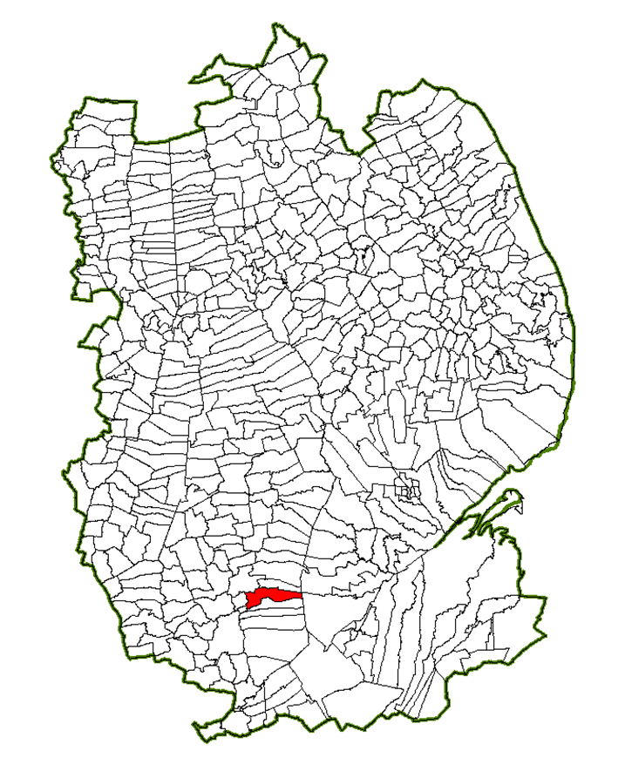

**Risk of Flooding Rivers and Sea – Rippingale**



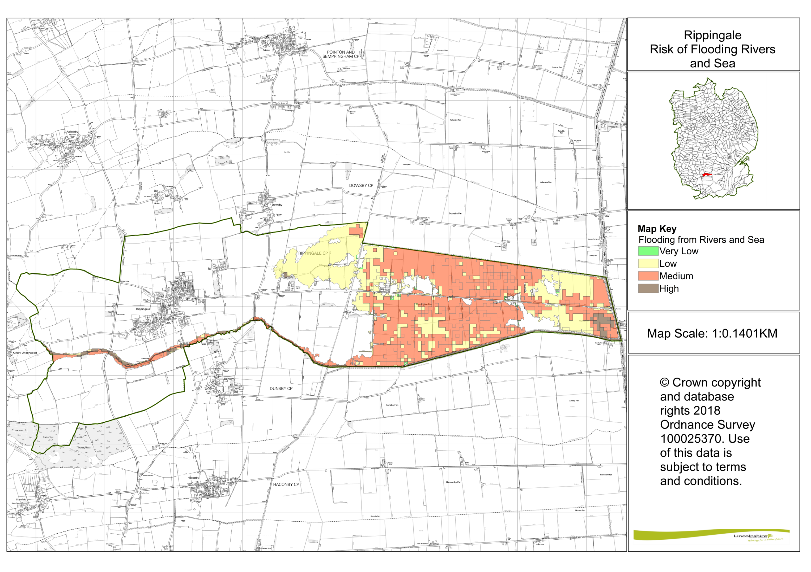

**Risk of Surface Water 30% (Depth) – Rippingale**

